**We Make You Shine**

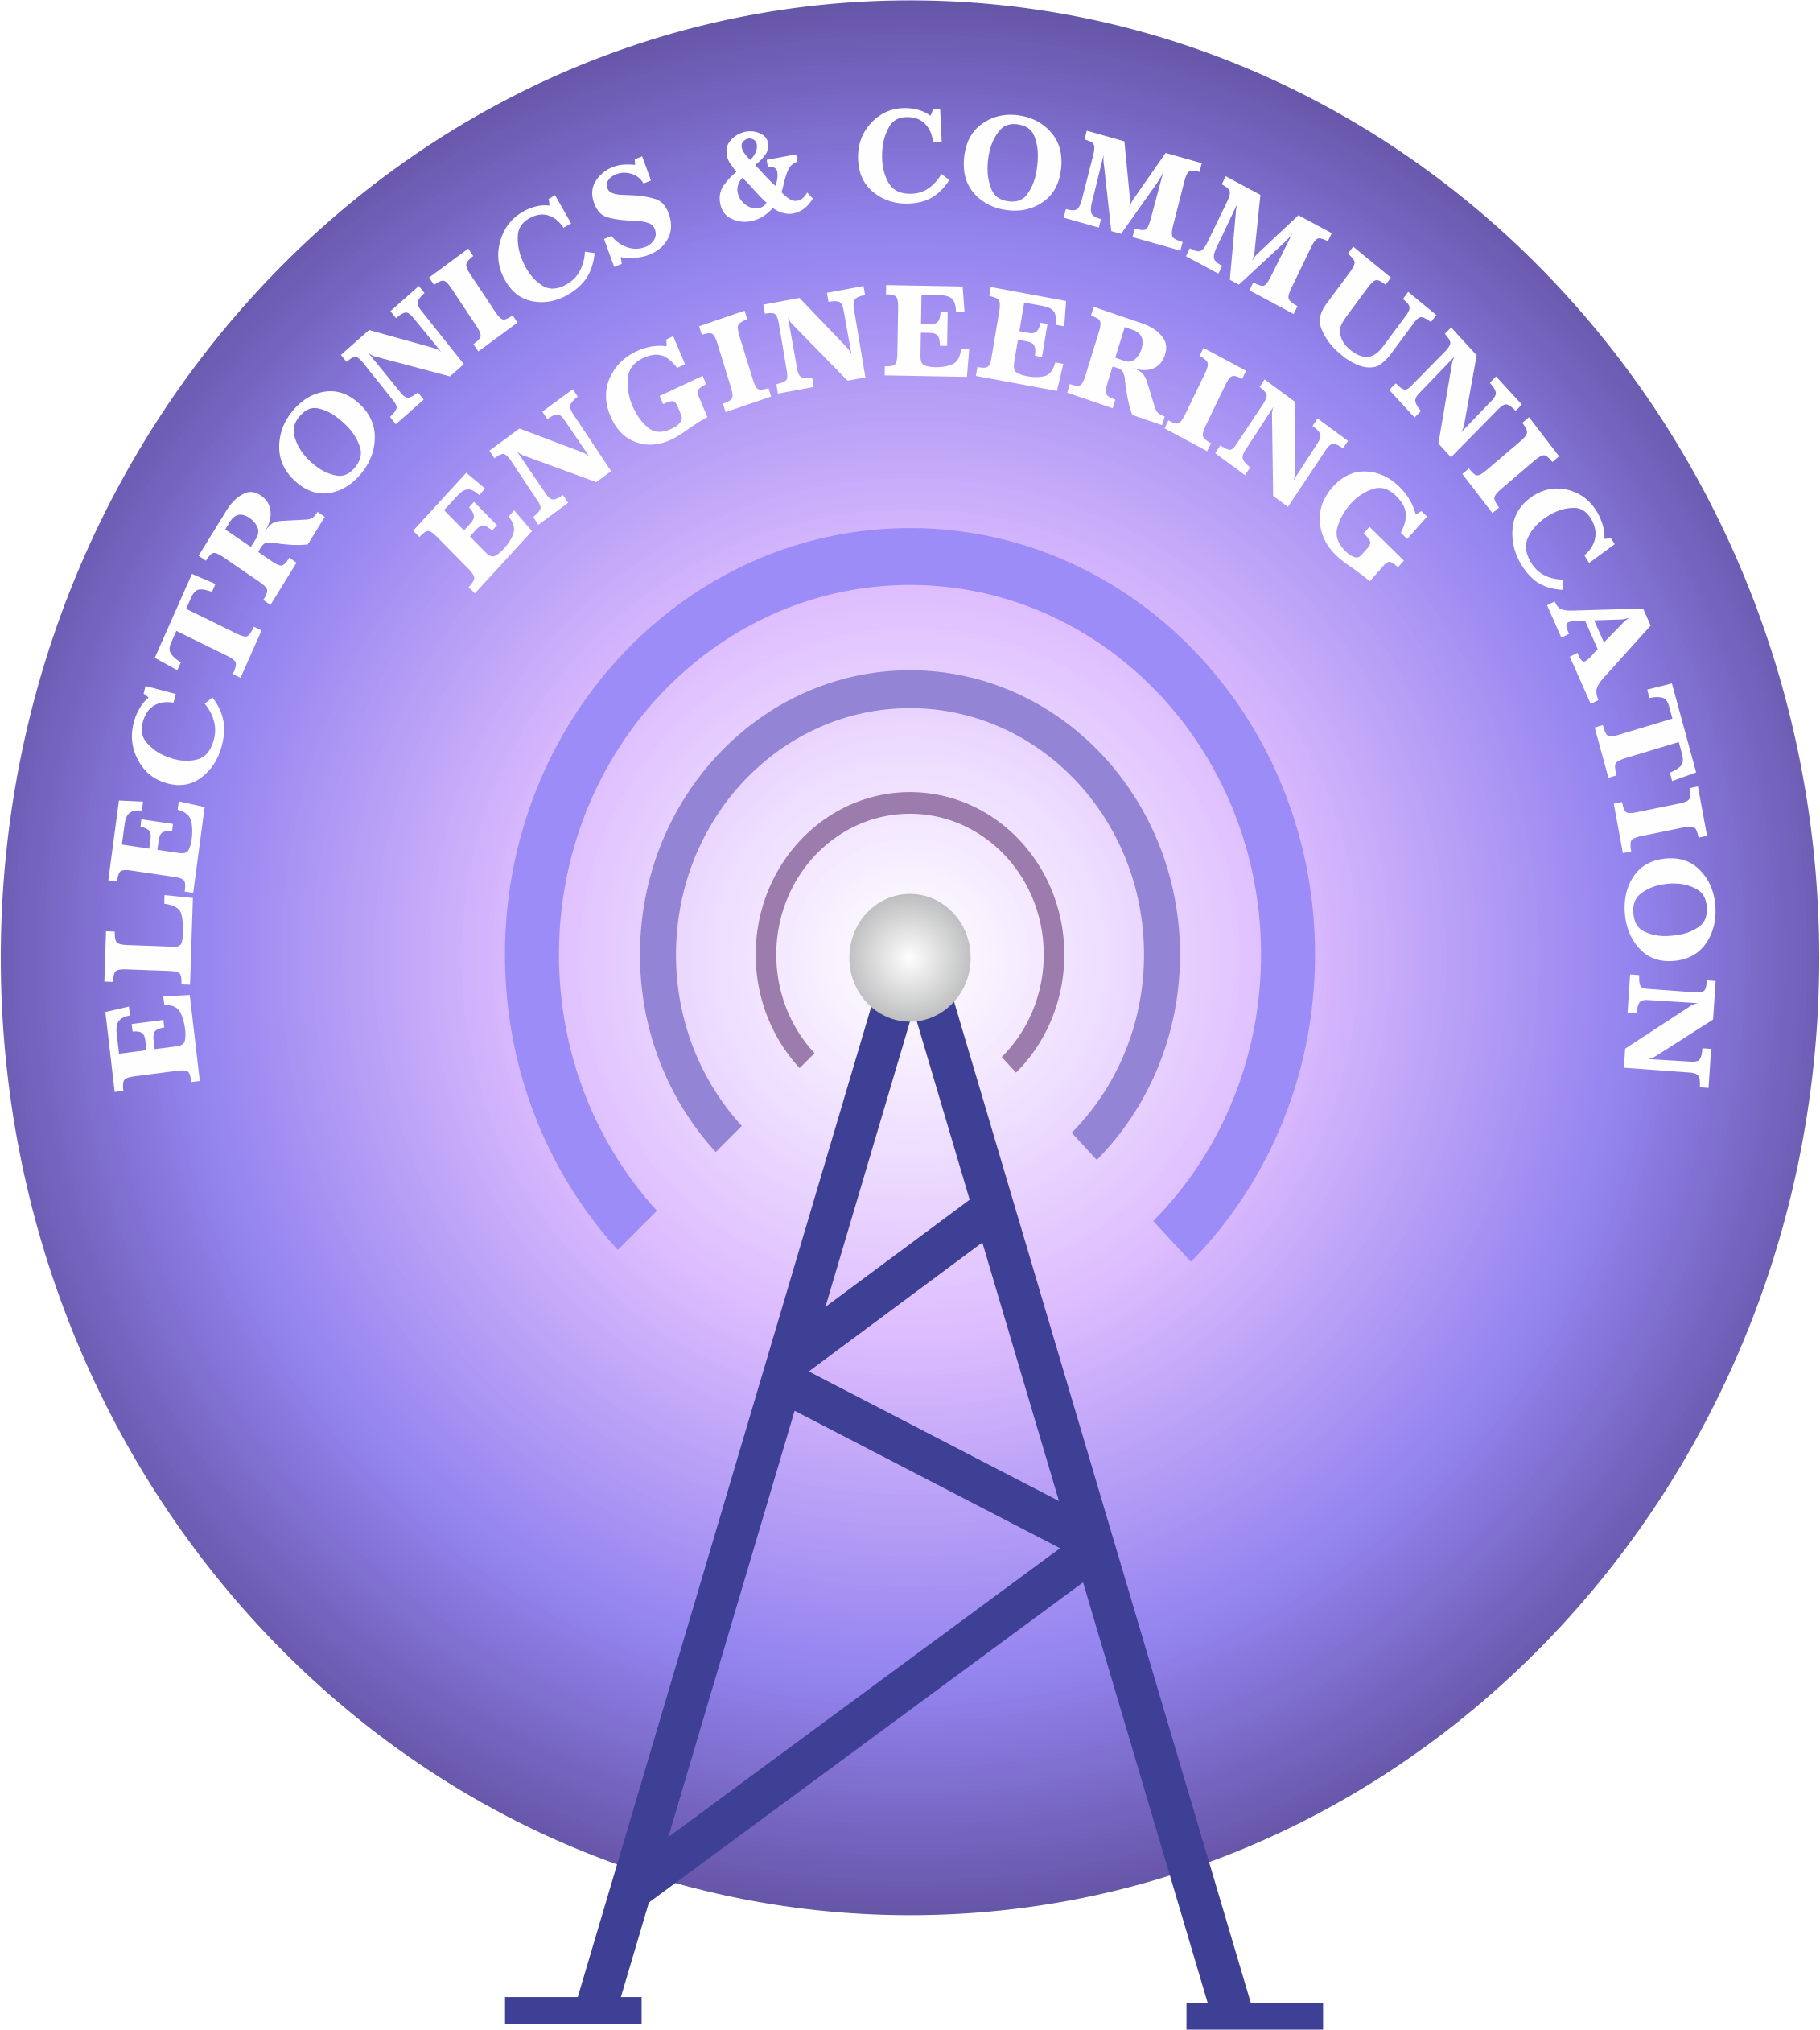

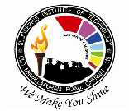

**St.Joseph’s Institute of technology**

**Chennai – 119.**

**Department of Electronics & Communication Engineering**

|  |
| --- |
| **AUTOMATIC OBSTACLE DETECTOR** |

**Abstract**

This system provides safe driving and enables the physically challenged people to drive vehicles. It detects the obstacle automatically and enable safety driving and prevents many accidents

**Block diagram:**

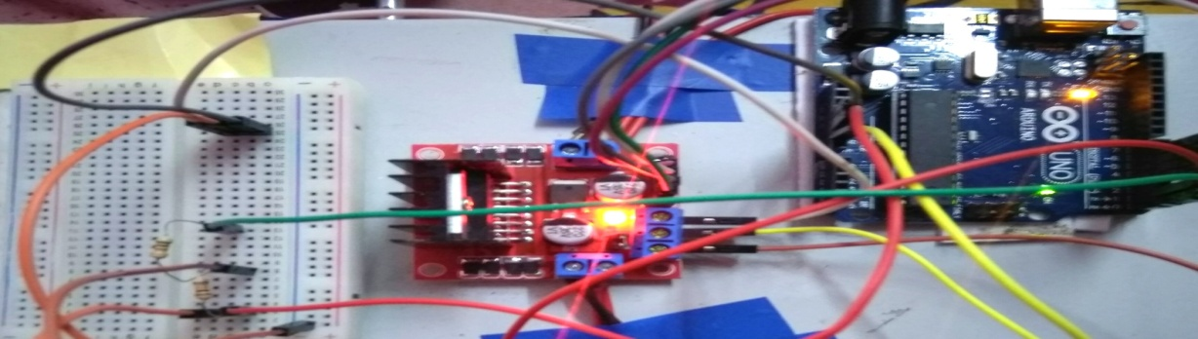

**Circuit diagram:**

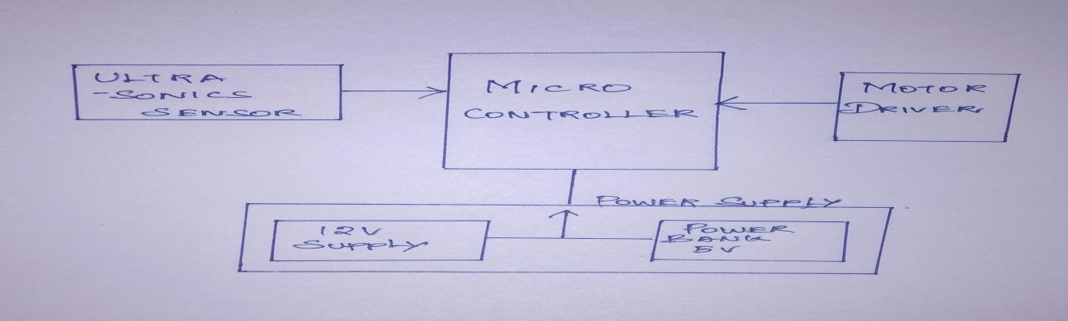

**Result:**

Thus the car is used to drive automatically with high safety protection. This type of automatic driving reduces the number of accidents.